Foundation Curriculum Topic Map
Foundation 1 - A



Our Ambition: To be the highest performing MAT in the country
Our Mission: To improve the communities we serve for the better

Vision:
Challenging educational orthodoxies so that every child makes good progress in all subjects;
all teachers are committed to personal improvement and fulfil their responsibilities;
all children receive an inspiring curriculum;
all academies strive to be outstanding.

 | Autumn 1 (F1) |  |  |  |  |  |  | Autumn 2 (F1)
 | Week 1 | Week 2 | Week 3 | Week 4 | Week 5 | Week 6 | Week 7 | Week 1 | Week 2 | Week 3 | Week 4 | Week 5 | Week 6 |  | Week 7
Topic | Marvellous Me |  |  |  |  |  |  | Festivals and Celebrations
Story Focus | 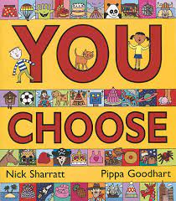  You choose |  | 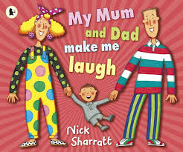  My Mum and Dad make me laugh |  | Elmer  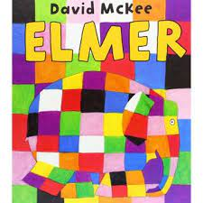 |  |  | 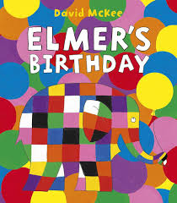  Elmer’s Birthday |  | 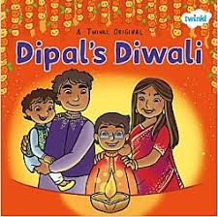  Dipal’s Diwali |  | 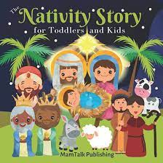  The Nativity |  | The Nativity
Communication and Language | Use the speech sounds p, b, m, w.  • Are usually still learning to pronounce:- l/r/w/y - s/sh/ch/dz/j- f/th - multi-syllabic words such as ‘banana’ and ‘computer’  Develop pretend play: ‘putting the baby to sleep’ or ‘driving the car to the shops’  Start to develop conversation, often jumping from topic to topic  Understand simple instructions like “give to mummy” or “stop  Listen to other people’s talk with interest, but can easily be distracted by other things  Develop pretend play: ‘putting the baby to sleep’ or ‘driving the car to the shops  Be able to express a point of view and to debate when they disagree with an adult o a friend, using words as well as actions.  Can start a conversation with an adult or a friend and continue it for many turns.  Can find it difficult to pay attention to more than one thing at a time. |  |  |  |  |  |  | Use the speech sounds p, b, m, w.  • Are usually still learning to pronounce:- l/r/w/y - s/sh/ch/dz/j- f/th - multi-syllabic words such as ‘banana’ and ‘computer’  Develop pretend play: ‘putting the baby to sleep’ or ‘driving the car to the shops’  Understand a question or instruction that has two parts, such as “Get your coat and wait at the door”.  Develop pretend play: ‘putting the baby to sleep’ or ‘driving the car to the shops  Be able to express a point of view and to debate when they disagree with an adult or a friend, using words as well as actions.  Can start a conversation with an adult or a friend and continue it for many turns.  Enjoy listening to longer stories and can remember much of what happens.  Use a wider range of vocabulary.  Can find it difficult to pay attention to more than one thing at a time.  Understand position through words alone – for example, “The bag is under the table,” – with no pointing.
Personal, Social and Emotional Development | Find ways to calm themselves, through being calmed and comforted by their key person  Establish their sense of self  Express preferences and decisions. They also try new things and start establishing their autonomy.  Find ways of managing transitions, for example from their parent to their key person  Notice and ask questions about differences, such as skin colour, types of hair, gender, special needs and disabilities, and so on. |  |  |  |  |  |  | Develop friendships with other children  Notice and ask questions about differences, such as skin colour, types of hair, gender, special needs and disabilities, and so on.  Express preferences and decisions. They also try new things and start establishing their autonomy.  Be increasingly able to talk about and manage their emotions.  Select and use activities and resources, with help when needed. This helps them to achieve a goal they have chosen, or one which is suggested to them.
Physical Development | REAL PE: Personal  Coordination Footwork (Week 1 -3)  Static balance (Week 3 – 7)  Use large and small motor skills to do things independently, for example manage buttons and zips, and pour drinks.  Sit on a push-along wheeled toy, use a scooter or ride a tricycle  Continue to develop their movement, balancing, riding (scooters, trikes and bikes) and ball skills.  Skip, hop, stand on one leg and hold a pose for a game like musical statues. |  |  |  |  |  |  | REAL PE: Social  Dynamic Balance and Agility (Week 1 – 3)  Static Balance – Seated (Week 4 – 7)  Use large and small motor skills to do things independently, for example manage buttons and zips, and pour drinks.  Show an increasing desire to be independent, such as wanting to feed themselves and dress or undress.  Skip, hop, stand on one leg and hold a pose for a game like musical statues.  Use a comfortable grip with good control when holding pens and pencils.

 | Autumn 1 (F1) |  |  |  |  |  |  |  |  |  |  |  |  |  |  | Autumn 2 (F1)
 | Week 1 |  | Week 2 |  | Week 3 |  | Week 4 |  | Week 5 |  |  | Week 6 |  | Week 7 |  | Week 1 |  | Week 2 |  |  |  | Week 3 | Week  4 | Week  5 |  |  |  | Week  6 | Week  7
Topic | Marvellous Me |  |  |  |  |  |  |  |  |  |  |  |  |  |  | Once upon a time
Story Focus | You choose |  |  |  | My Mum and Dad make me laugh |  |  |  | Elmer |  |  |  |  |  |  | Elmer’s Birthday |  |  |  |  | Dipal’s Diwali |  |  |  | The Nativity Story |  |  |  | The Nativity Story
Literacy | Say some of the words in songs and rhymes.  Enjoy sharing books with an adult.  Pay attention and responds to the pictures or the words.  Notice some print, such as the first letter of their name, a bus or door number, or a familiar logo.  Enjoy drawing freely. |  |  |  |  |  |  |  |  |  |  |  |  |  |  | Say some of the words in songs and rhymes.  Sing songs and say rhymes independently, for example, singing whilst playing.  Have favourite books and seeks them out, to share with an adult, with another child, or to look at alone.  Repeat words and phrases from familiar stories.  Ask questions about the book. Makes comments and shares their own ideas.  Develop play around favourite stories using props.  Enjoy drawing freely.  Add some marks to their drawings, which they give meaning to. For example: “That says mummy.”  Make marks on their picture to stand for their name.
Mathematics | Combine objects like stacking blocks and cups. Put objects inside others and take them out again.  Take part in finger rhymes with numbers.  Counting-like behaviour, such as making sounds, pointing or saying some numbers in sequence.  Build with a range of resources. |  |  |  |  |  |  |  |  |  |  |  |  |  |  | Take part in finger rhymes with numbers.  React to changes of amount in a group of up to three items.  Count in everyday contexts, sometimes skipping numbers - ‘1-2-3-5.’  .
Understanding of the World | Make connections between the features of their family and other families.  Notice differences between people.  Begin to make sense of their own life-story and family’s history.
Expressive Arts and Design | Start to make marks intentionally.  Explore paint, using fingers and other parts of their bodies as well as brushes and other tools.  Enjoy and take part in action songs, such as ‘Twinkle, Twinkle Little Star’. |  |  |  |  |  |  |  |  |  |  |  |  |  |  | Start to make marks intentionally.  Explore paint, using fingers and other parts of their bodies as well as brushes and other tools.  Express ideas and feelings through making marks, and sometimes give a meaning to the marks they make.  Enjoy and take part in action songs, such as ‘Twinkle, Twinkle Little Star’.  Make simple models which express their ideas.  Explore colour and colour-mixing.
Jigsaw | Being me in my world:  - I understand how it feels to belong and that we are similar and different  - I understand how feeling happy and sad can be expressed  - I can work together and consider other people’s feelings  - I can use gentle hands and understand that it is good to be kind to people  - I am starting to understand children’s rights and this means we should all be allowed to learn and play  - I am learning what being responsible means |  |  |  |  |  |  |  |  |  |  |  |  |  |  | Celebrating difference:  - I know how it feels to be proud of something I am good at.  - I can tell you one way I am special and unique.  - I know that all families are different.  - I know there are lots of different homes.  - I can tell you how I could make new friends.  - I can use my words to stand up for myself.
Hooks and Events | Baseline assessments  Sharing family photographs  Books and Biscuits event  Throw autumn leaves in the air |  |  |  |  |  |  |  |  |  |  |  |  |  |  | Bonfire night – 5th November  Remembrance day – 11th November  Diwali – 1st November  Nativity performance –  Christmas craft afternoon  Pantomime  Go to a pantomime – In school 3rd December 2024  Take part in a show –  Play Apple bobbing  Play party games like pass the parcel
 |  | Spring 1 (F1) |  |  |  |  |  |  |  |  |  |  |  |  | Spring 2 (F1)
 |  | Week 1 |  | Week 2 |  | Week 3 |  | Week 4 |  |  | Week 5 |  | Week 6 |  | Week 1 |  | Week 2 |  |  | Week 3 |  |  |  |  | Week 4 |  | Week 5 |  | Week 6
Topic |  | People who help us |  |  |  |  |  |  |  |  |  |  |  |  | Rumble in the jungle
Story Focus |  | People who help us: Fire Fighters  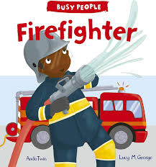 |  |  |  | People who help us: Police Officer  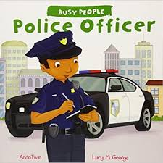 |  |  |  | People who help us: Doctors  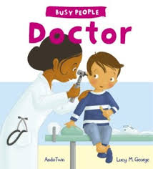 |  |  |  |  | Monkey Puzzle  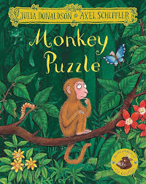 |  |  |  | Giraffe’s can’t dance  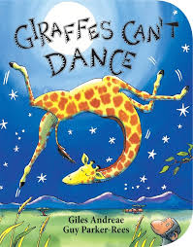 |  |  |  |  |  |  | The Tiger who came to tea  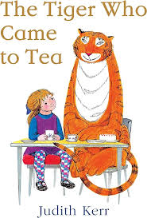
Communication and Language |  | Enjoy singing, music and toys that make sounds  Understand a question or instruction that has two parts, such as “Get your coat and wait at the door”.  Be able to express a point of view and to debate when they disagree with an adult or a friend, using words as well as actions.  Can start a conversation with an adult or a friend and continue it for many turns.  Enjoy listening to longer stories and can remember much of what happens.  Use a wider range of vocabulary. |  |  |  |  |  |  |  |  |  |  |  |  | Enjoy singing, music and toys that make sounds  Understand a question or instruction that has two parts, such as “Get your coat and wait at the door”.  Be able to express a point of view and to debate when they disagree with an adult or a friend, using words as well as actions.  Can start a conversation with an adult or a friend and continue it for many turns.  Enjoy listening to longer stories and can remember much of what happens.  Use a wider range of vocabulary.  May have problems saying:- some sounds: r, j, th, ch, and sh- multisyllabic words such as ‘pterodactyl’, ‘planetarium’ or ‘hippopotamus’
Personal, Social and Emotional Development |  | Are talking about their feelings in more elaborated ways: “I’m sad because...” or “I love it when ...”.  Select and use activities and resources, with help when needed. This helps them to achieve a goal they have chosen, or one which is suggested to them. |  |  |  |  |  |  |  |  |  |  |  |  | Feel confident when taken out around the local neighbourhood, and enjoy exploring new places with their key person  Are talking about their feelings in more elaborated ways: “I’m sad because...” or “I love it when ...”.  Select and use activities and resources, with help when needed. This helps them to achieve a goal they have chosen, or one which is suggested to them.  Play with one or more other children, extending and elaborating play ideas.  Increasingly follow rules, understanding why they are important.

 | Spring 1 (F1) |  |  |  |  |  |  | Spring 2 (F1)
 | Week 1 | Week 2 | Week 3 | Week 4 |  | Week 5 | Week 6 | Week 1 | Week 2 |  | Week 3 | Week 4 |  | Week 5 | Week 6
Topic | People who help us |  |  |  |  |  |  | Rumble in the Jungle
Story Focus | People who help us: Firefighters |  | People who help us: Police Officers |  | People who help us:  Doctors |  |  | Monkey Puzzle |  | Giraffe’s can’t dance |  |  | The Tiger who came to tea
Physical Development | REAL PE: Cognitive  Dynamic Balance – On a line (Week 1 – 3)  Static Balance – Tight rope (Week 3 – 6)  Clap and stamp to music  Show an increasing desire to be independent, such as wanting to feed themselves and dress or undress.  Start taking part in some group activities which they make up for themselves, or in teams.  Use a comfortable grip with good control when holding pens and pencils. |  |  |  |  |  |  | REAL PE: Creative  Coordination – Ball skills (Week 1 – 3)  Counter Balance with a partner (Week 3 – 6 )  Start taking part in some group activities which they make up for themselves, or in teams.  Use a comfortable grip with good control when holding pens and pencils.  Make healthy choices about food, drink, activity and toothbrushing.  Use one-handed tools and equipment, for example, making snips in paper with scissors.
Literacy | Add some marks to their drawings, which they give meaning to. For example: “That says mummy.”  Make marks on their picture to stand for their name.  Write some letters accurately. |  |  |  |  |  |  | Engage in extended conversations about stories, learning new vocabulary.  Use some of their print and letter knowledge in their early writing. For example: writing a pretend shopping list that starts at the top of the page; write ‘m’ for mummy.  Write some or all of their name.
Mathematics | Compare amounts, saying ‘lots’, ‘more’ or ‘same’.  Compare sizes, weights etc. using gesture and language - ‘bigger/little/smaller’, ‘high/low’, ‘tall’, ‘heavy’.  Fast recognition of up to 3 objects, without having to count them individually (‘subitising’).  Recite numbers past 5.  Say one number for each item in order: 1,2,3,4,5.  Compare quantities using language: ‘more than’, ‘fewer than’.  Talk about and explore 2D and 3D shapes (for example, circles, rectangles, triangles and cuboids) using informal and mathematical language: ‘sides’, ‘corners’; ‘straight’, ‘flat’, ‘round’.  Select shapes appropriately: flat surfaces for building, a triangular prism for a roof etc. |  |  |  |  |  |  | Notice patterns and arrange things in patterns.  Fast recognition of up to 3 objects, without having to count them individually (‘subitising’).  Recite numbers past 5.  Say one number for each item in order: 1,2,3,4,5.  Link numerals and amounts: for example, showing the right number of objects to match the numeral, up to 5.  Make comparisons between objects relating to size, length, weight and capacity.
Understanding of the World | Notices differences between people.  Use all their senses in hands-on exploration of natural materials.  Talk about what they see, using a wide vocabulary.  Shows interest in different occupations  Continue developing positive attitudes about the differences between people. |  |  |  |  |  |  | Talk about what they see, using a wide vocabulary.  Explore collections of materials with similar and/or different properties.
Expressive Arts and Design | Show attention to sounds and music.  Respond emotionally and physically to music when it changes.  Move and dance to music.  Anticipate phrases and actions in rhymes and songs, like ‘Peepo’.  Explore their voices and enjoy making sounds.  Explore a range of sound-makers and instruments and play them in different ways.  Explore different materials, using all their senses to investigate them. Manipulate and play with different materials.  Begin to develop complex stories using small world equipment like animal sets, dolls and dolls houses etc.  Explore colour and colour-mixing.  Play instruments with increasing control to express their feelings and ideas. |  |  |  |  |  |  | Explore different materials freely, in order to develop their ideas about how to use them and what to make.  Draw with increasing complexity and detail, such as representing a face with a circle and including details.  Explore colour and colour-mixing.
Jigsaw | Dreams and goals:  - I understand what a challenge means  - I can keep trying until I can do something  - I can set a goal and work towards it  - I know some kind words which can encourage people  - I can start to think about the jobs I might like to do when I’m older  - I can feel proud when I achieve a goal |  |  |  |  |  |  | Healthy me:  - I know the names for some parts of my body and am starting to understand that I need to be active to be healthy.  - I can tell you some of the things I need to do to be healthy.  - I know what the word ‘healthy’ means and that some foods are heathier than others.  - I know how to help myself go to sleep and that sleep is good for me.  - I can wash my hands and know it is important to do this before I eat and after I go to the toilet.  - I know who my safe adults are and how to stay safe if they are not close by me.
Hooks and Events | Fire truck visit  Barefoot Walk  Chinese New year –  Books and Biscuits –  Safer Internet day –  Walk barefoot in sand/mud or even jelly |  |  |  |  |  |  | Pancake day – 4th March  St David’s day – 1st March  World book day – 6th March  Mother’s day – 30th March  St Patricks day – 17th March  Parent Craft afternoon –  St George’s day – 23rd April  Have a picnic indoors and outdoors  Stroke a rabbit

 | Summer 1 (F1) |  |  |  |  |  |  | Summer 2 (F1)
 | Week 1 | Week 2 | Week 3 | Week 4 |  | Week 5 | Week 6 | Week 1 | Week 2 |  | Week 3 | Week 4 | Week 5 |  | Week 6
Topic | Wonderful Wheels |  |  |  |  |  |  | What’s on your plate?
Story Focus | 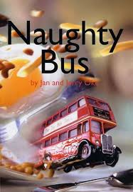  The Naughty Bus |  | Choo, choo, clickery, clack  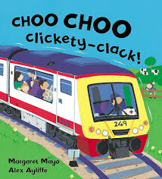 |  | Big Blue Train  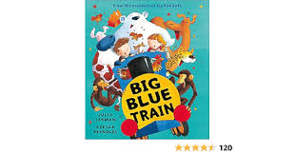 |  |  | Oliver’s fruit salad  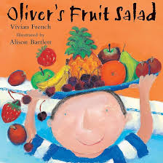 |  | My food, your food, our food  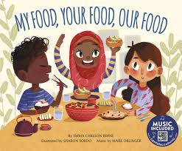 |  |  |  | Oliver’s vegetables  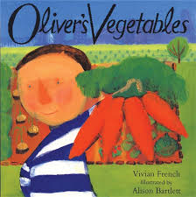
Communication and Language | Use longer sentences of four to six words.  Sing a large repertoire of songs.  Know many rhymes, be able to talk about familiar books, and be able to tell a long story.  Enjoy listening to longer stories and can remember much of what happens.  Use a wider range of vocabulary. |  |  |  |  |  |  | Use longer sentences of four to six words.  Sing a large repertoire of songs.  Know many rhymes, be able to talk about familiar books, and be able to tell a long story.  Enjoy listening to longer stories and can remember much of what happens.  Use a wider range of vocabulary.
Personal, Social and Emotional Development | Play with one or more other children, extending and elaborating play ideas.  Help to find solutions to conflicts and rivalries. For example, accepting that not everyone can be Spider-Man in the game, and suggesting other ideas.  Increasingly follow rules, understanding why they are important.  Talk about their feelings using words like ‘happy’, ‘sad’, ‘angry’ or ‘worried’. |  |  |  |  |  |  | Play with one or more other children, extending and elaborating play ideas.  Help to find solutions to conflicts and rivalries. For example, accepting that not everyone can be Spider-Man in the game, and suggesting other ideas.  Increasingly follow rules, understanding why they are important.  Develop appropriate ways of being assertive.  Talk about their feelings using words like ‘happy’, ‘sad’, ‘angry’ or ‘worried’.  Begin to understand how others might be feeling.

 | Summer 1 (F1) |  |  |  |  |  |  | Summer 2 (F1)
 | Week 1 | Week 2 | Week 3 | Week 4 |  | Week 5 | Week 6 | Week 1 | Week 2 |  | Week 3 | Week 4 | Week 5 |  | Week 6
Topic | Wonderful Wheels |  |  |  |  |  |  | What’s on your plate?
Story Focus | The Naughty bus |  | Choo, choo, clickery, clack |  | The Big Blue Train |  |  | Oliver’s fruit salad |  | My food, your food, our food |  |  |  | Oliver’s vegetables
Physical Development | REAL PE: Physical  Coordination – Receiving and sending (Week 1 – 3)  Agility (Week 3 – 6)  Are increasingly able to use and remember sequences and patterns of movements which are related to music and rhythm.  Use a comfortable grip with good control when holding pens and pencils.  Be increasingly independent as they get dressed and undressed, for example, putting coats on and doing up zips.  Make healthy choices about food, drink, activity and toothbrushing. |  |  |  |  |  |  | REAL PE: Health and Fitness  Agility – Ball chasing (Week 1 -3)  Static Foot balance (Week 3 – 6)  Are increasingly able to use and remember sequences and patterns of movements which are related to music and rhythm.  Match their developing physical skills to tasks and activities in the setting. For example, they decide whether to crawl, walk or run across a plank, depending on its length and width.  Use a comfortable grip with good control when holding pens and pencils.  Be increasingly independent as they get dressed and undressed, for example, putting coats on and doing up zips.
Literacy | Understand the five key concepts about print:  - print has meaning  – the names of the different parts of a book  - print can have different purposes  - page sequencing  - we read English text from left to right and from top to bottom  Develop their phonological awareness, so that they can:- spot and suggest rhymes- count or clap syllables in a word- recognise words with the same initial sound, such as money and mother  Engage in extended conversations about stories, learning new vocabulary.  Write some or all of their name. |  |  |  |  |  |  | Understand the five key concepts about print:  - print has meaning  – the names of the different parts of a book  - print can have different purposes  - page sequencing  - we read English text from left to right and from top to bottom  Develop their phonological awareness, so that they can:- spot and suggest rhymes- count or clap syllables in a word- recognise words with the same initial sound, such as money and mother  Engage in extended conversations about stories, learning new vocabulary.  Write some or all of their name.
Mathematics | Talk about and explore 2D and 3D shapes (for example, circles, rectangles, triangles and cuboids) using informal and mathematical language: ‘sides’, ‘corners’; ‘straight’, ‘flat’, ‘round’.  Select shapes appropriately: flat surfaces for building, a triangular prism for a roof etc.  Describe a familiar route.  Talk about and identifies the patterns around them. For example: stripes on clothes, designs on rugs and wallpaper. Use informal language like ‘pointy’, ‘spotty’, ‘blobs’ etc.  Extend and create ABAB patterns – stick, leaf, stick, leaf.  Notice and correct an error in a repeating pattern. |  |  |  |  |  |  | Talk about and explore 2D and 3D shapes (for example, circles, rectangles, triangles and cuboids) using informal and mathematical language: ‘sides’, ‘corners’; ‘straight’, ‘flat’, ‘round’.  Select shapes appropriately: flat surfaces for building, a triangular prism for a roof etc.  Combine shapes to make new ones – an arch, a bigger triangle etc.  Begin to describe a sequence of events, real or fictional, using words such as ‘first’, ‘then...’
Understanding of the World | Talk about what they see, using a wide vocabulary.  Show interest in different occupations.  Explore and talk about different forces they can feel. |  |  |  |  |  |  | Talk about what they see, using a wide vocabulary.  Continue to develop positive attitudes about the differences between people.  Know that there are different countries in the world and talk about the differences they have experienced or seen in photos.
Expressive Arts and Design | Explore different materials freely, in order to develop their ideas about how to use them and what to make.  Develop their own ideas and then decide which materials to use to express them.  Create closed shapes with continuous lines, and begin to use these shapes to represent objects.  Draw with increasing complexity and detail, such as representing a face with a circle and including details.  Explore colour and colour-mixing.  Remember and sing entire songs.  Sing the pitch of a tone sung by another person (‘pitch match’).  Play instruments with increasing control to express their feelings and ideas. |  |  |  |  |  |  | Explore different materials freely, in order to develop their ideas about how to use them and what to make.  Develop their own ideas and then decide which materials to use to express them.  Create closed shapes with continuous lines, and begin to use these shapes to represent objects.  Draw with increasing complexity and detail, such as representing a face with a circle and including details.  Explore colour and colour-mixing.  Remember and sing entire songs.  Sing the pitch of a tone sung by another person (‘pitch match’)  Create their own songs, or improvise a song around one they know.  Play instruments with increasing control to express their feelings and ideas.
Jigsaw | Relationship:  - I can tell you about my family.  - I understand how to make friends if I feel lonely.  - I can tell you some of the things I like about my friends.  - I know what to say and do if somebody is mean to me.  - I can use Calm Me time to manage my feelings.  - I can work together and enjoy being with my friends |  |  |  |  |  |  | Changing me:  - I can name parts of my body and show respect for myself.  - I can tell you some things I can do and some food I can eat to be healthy.  - I understand that we all start as babies and grow into children and then adults.  - I know that I grow and change.  - I can talk about how I feel moving to School from Nursery  - I can remember some fun things about Nursery this year.
Hooks and Events | Books and Biscuits – 8th May |  |  |  |  |  |  | Father’s day –  Sports day –  Build a giant sandcastle.  Go on a treasure hunt  Eat an ice cream cone  Run in and out of a hose pipe spray

